Issue: Target costing not updated for production order-version 2
RCA: In EBEW-sale order stock valuation -current valuation strategy is updated as 3 causing target costing issue
Resolution: CVS should be 1 to update for particular material and sales order target cost, in KKBC_ORD, maintain table with CVS as 1 and run ZCK55 and KKS2-variance analysis
Before change table
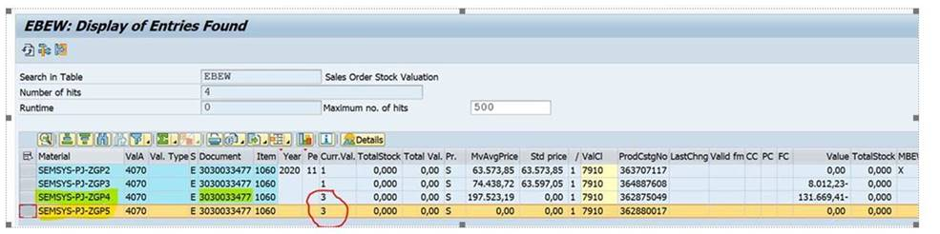
After changing table
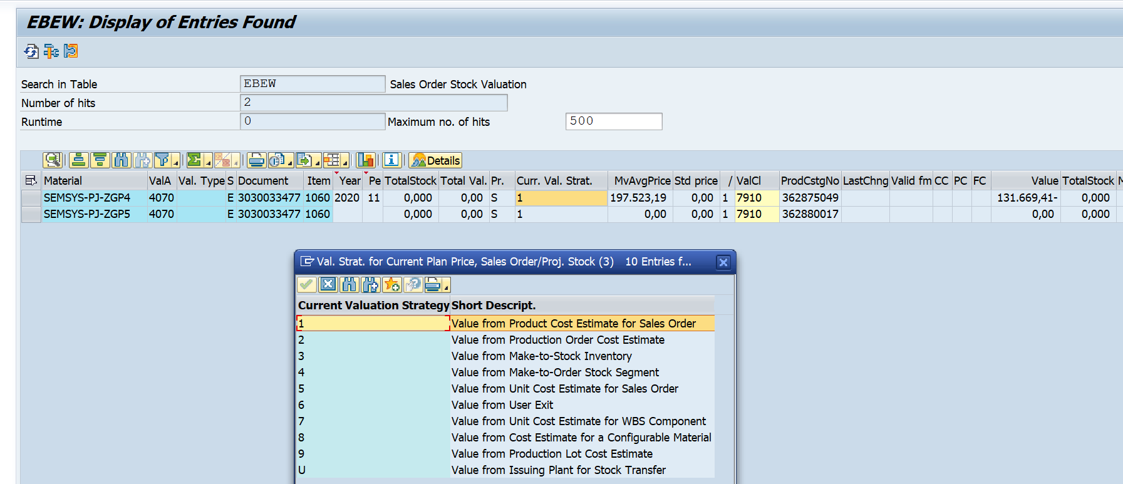
Kkbc_ord
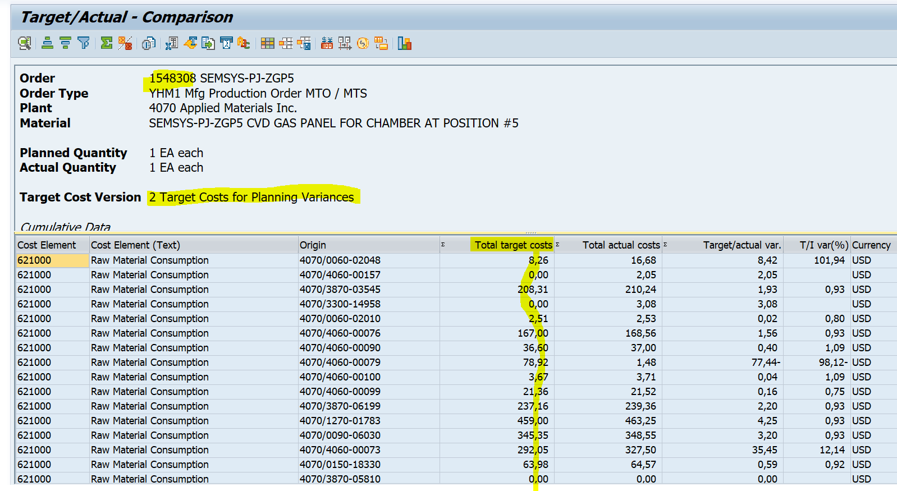

Sequence of production order:
Imp point: Before doing any goods movement CSER error must be clear in PO
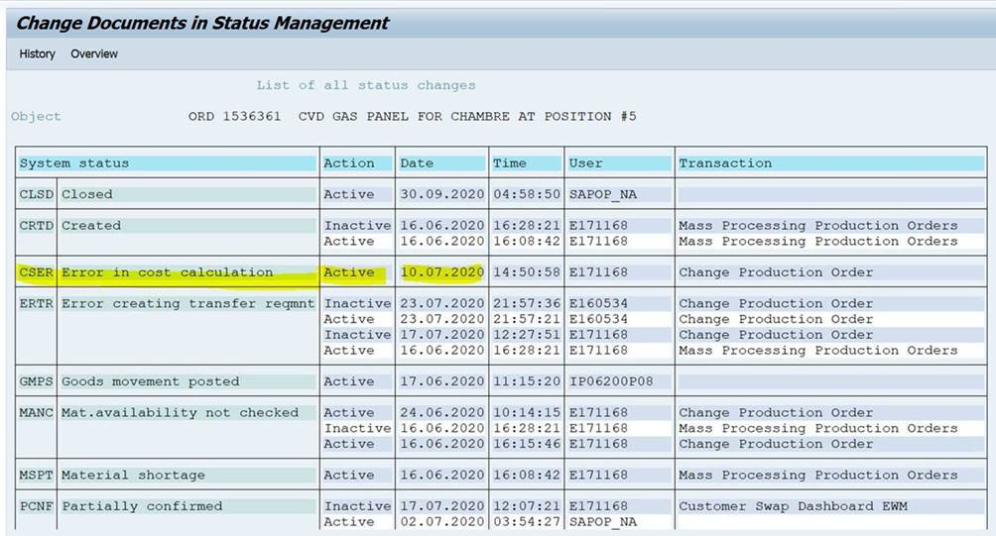
Corrective action: Please make sure that before releasing the production order CSER error is cleared, then done the inventory movement and follow the below sequence.
*goods issue
*goods receipt
*do the VCAL
*TECO the PO
*CLSD the PO
Should not do the TECOed before GR
While save the PO the below error must be cleared
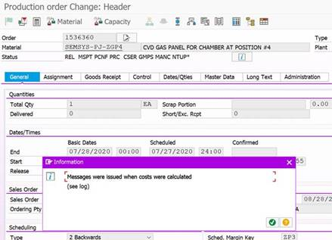
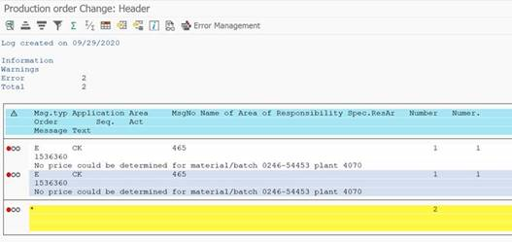

Issue 2:
Marked SO costing not found for valuation “0”-GR issue
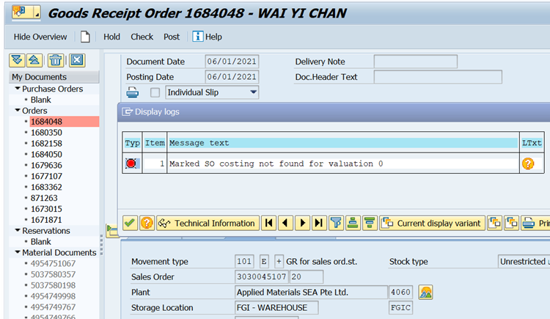
Cause: the above error coming due to below issues..
- sale order costing issue- EK02 and ZK02/or any one condition type missing in VA03
resolution: batch job issue, sub parts not having costing in mat master
do costing for sub parts and run ZCK55 to updated SO costing for LC,GC
b) activity rate missing in KP26 as per below screenshot
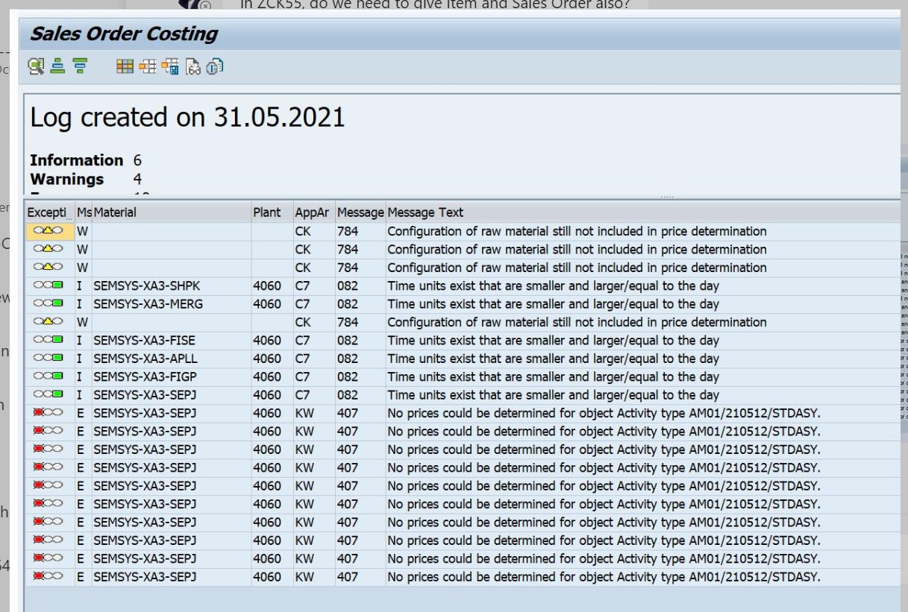
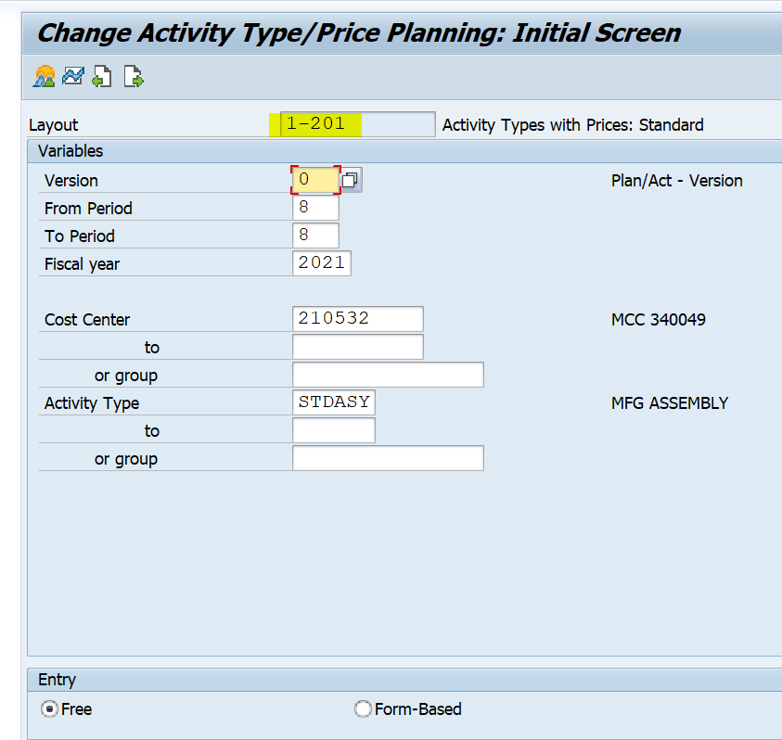
Sol: maintain rates in KP26 and proceed with ZCK55 to solve SO costing issue
c)sale order BOM components not having the costing relevancy in CS63 as below.

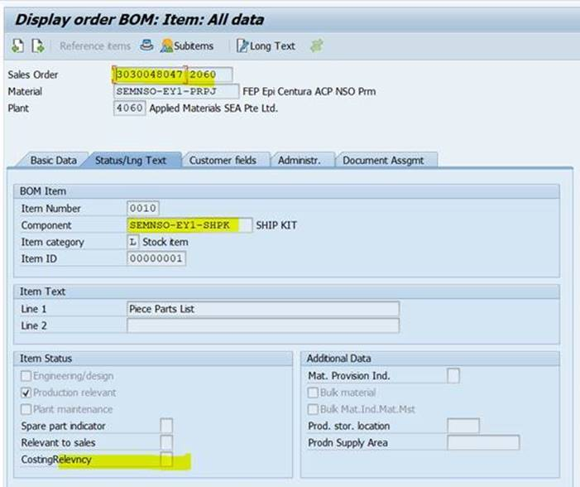
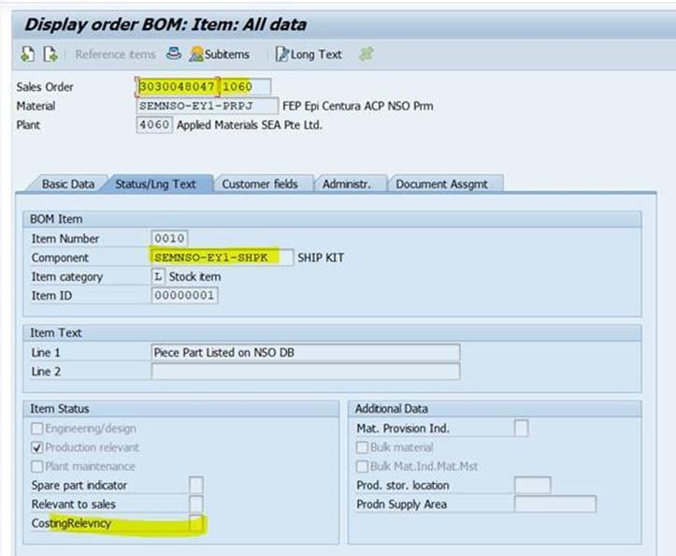

Mark the costing relevancy check box in SO BOM and proceed with ZCK55/CK55 to update so costing
4)Issue: Target qty is not matched with the sale order BOM qty in KKBC_ORD
Cause: due to added emergency parts in production order BOM components and marked as costing relevancy, system will take the qty from prd order and not from sale order.(PP issue)
Sol: remove costing relevancy for those EMER(emergency parts) in Prd order and run KKS2
Now target qty is matched with SO BOM qty.

5) KKBC is not calling target QTY for XXXX(PN)
Cause: due to added emergency parts in production order components, system taken the qty from PO and not from sale order BOM.
Planning cost and qty-Prodn order and prd order components
Target cost and qty-sale order costing and sale order BOM
Actual cost and actual qty- based on actual consumption
KKBC_ORD view
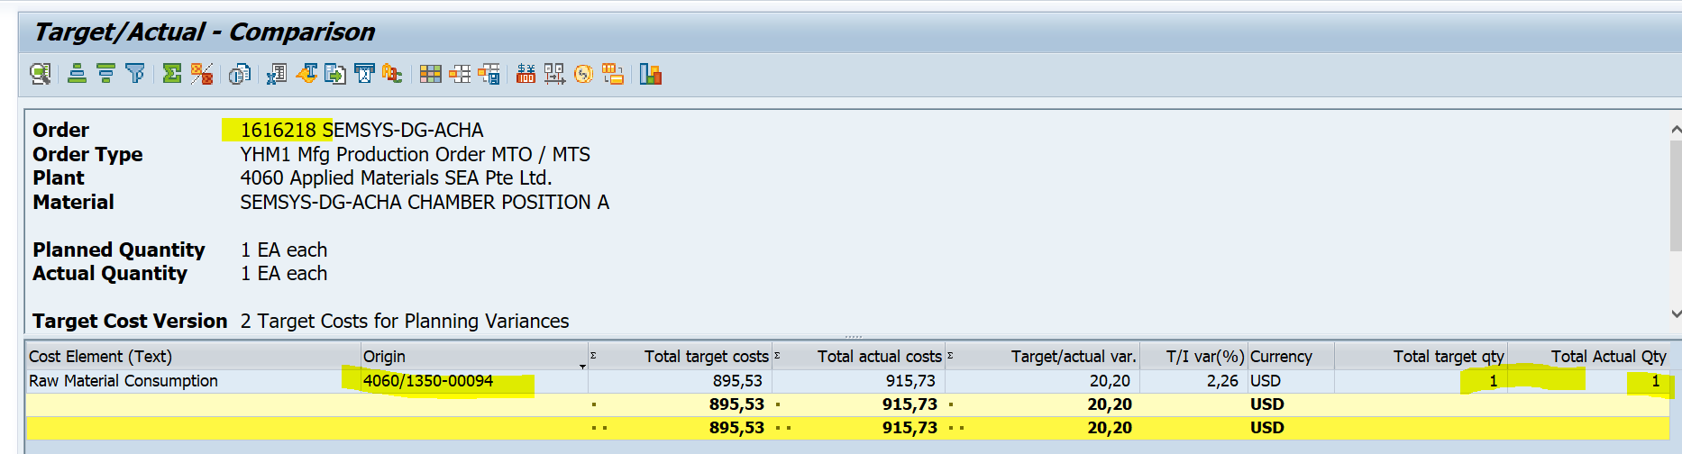
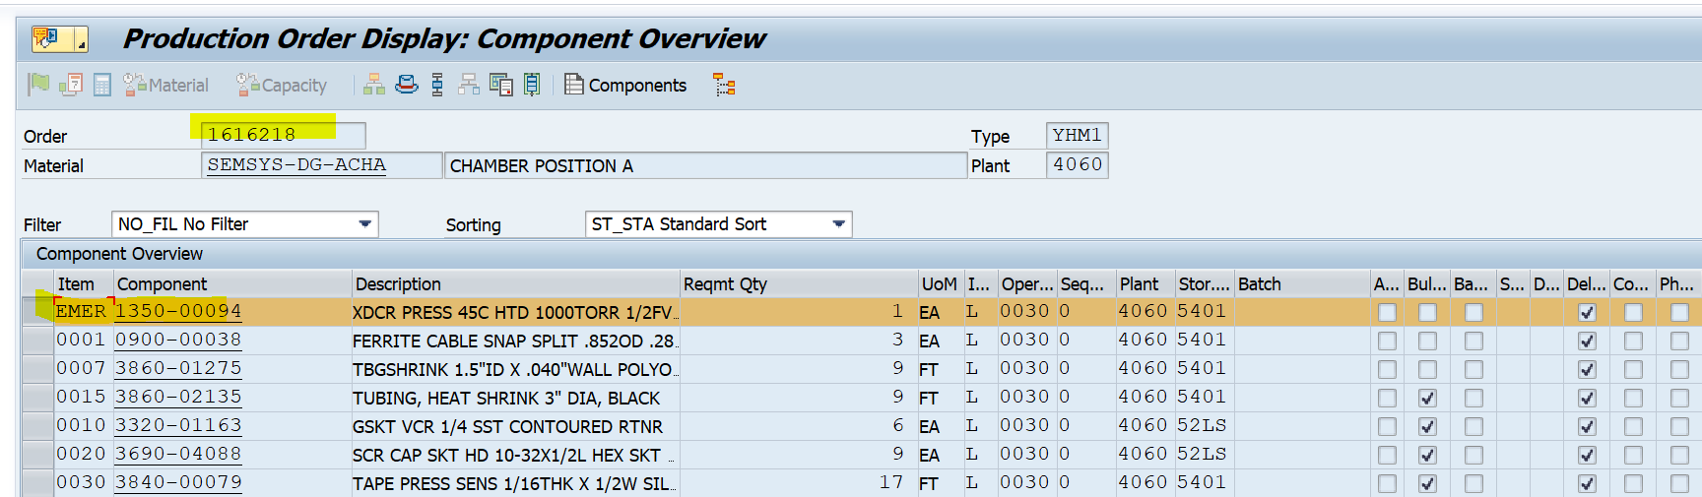
Remove costing relevancy from the EMER parts and run the KKS2 so that system updated the correct target qty.

Issue 5:
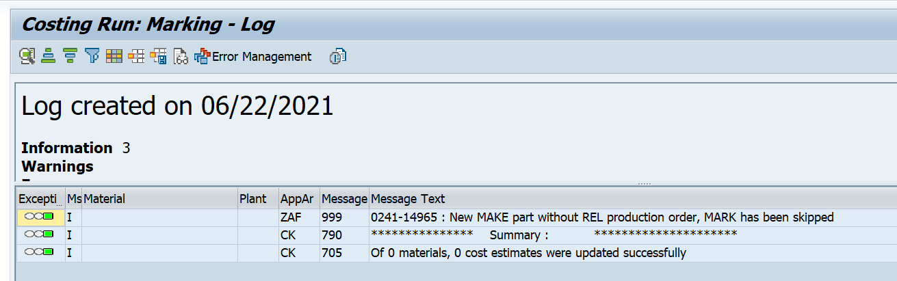
Sol: Process order need to release, then try to ck40n marking and release(business user activity)

Issue 6:
Period changing issue in marking and release for std cost.
Sol: check the period and run the costing in current period only.
Go to MMPV and open current period for MM
Check marking authorization for particular company code in CK24
Error:
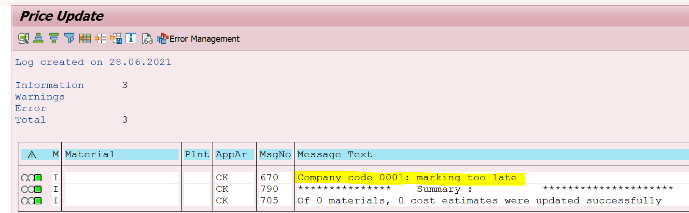

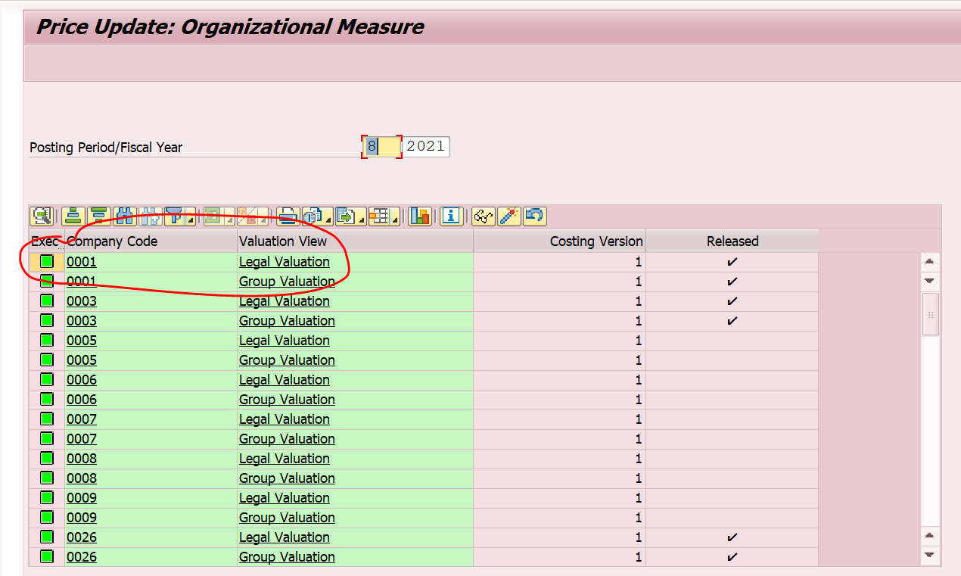

Issue 7.
Std cost inconsistency issue.
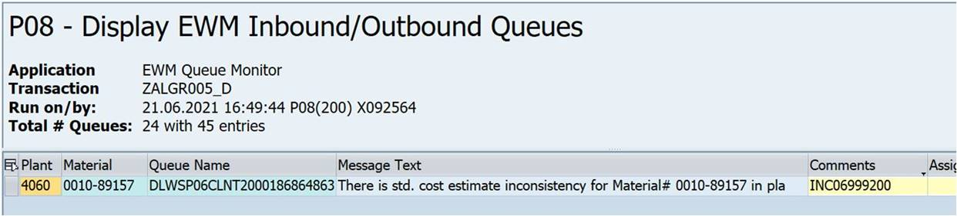
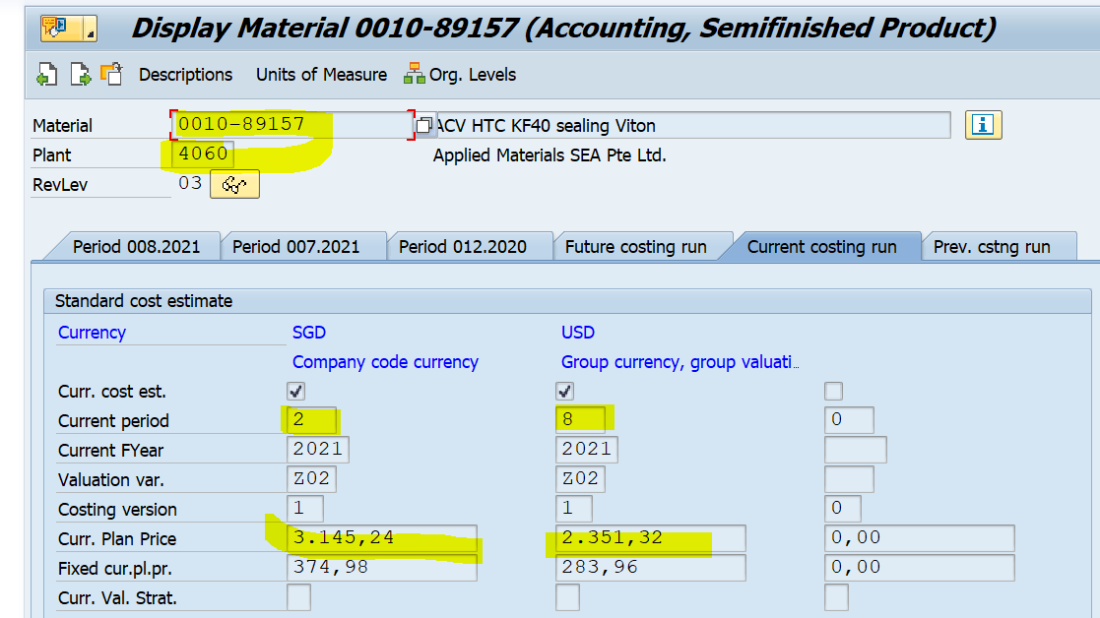
Issue: in the above screenshot the LC updated in P2 and GC updated in P8,
This issue is coming because batch run/job failed to update GC but updated LC
So, while doing the GR part is stucked in queue because of costing inconsistency issue
Prerequisite is while doing the GR, system checking the std cost in the current period.
Sol:
- update std cost in current period for LC,GC
- do the GR reversal (EWM team)
- re do the GR(business side)

issue 8.
Issue: month end COPA reconciliation, LC not flown to COPA, LC missing
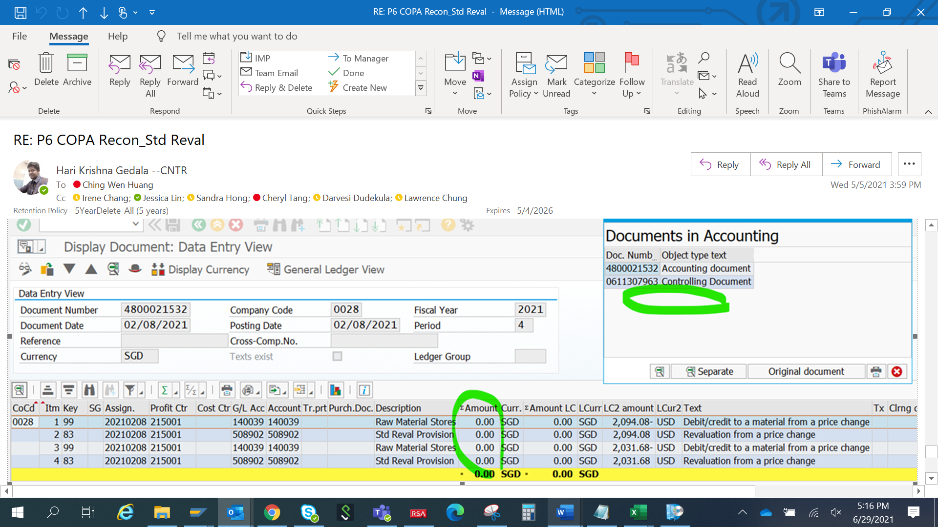
if the accounting doc does not have LC, then the value not flow to COPA
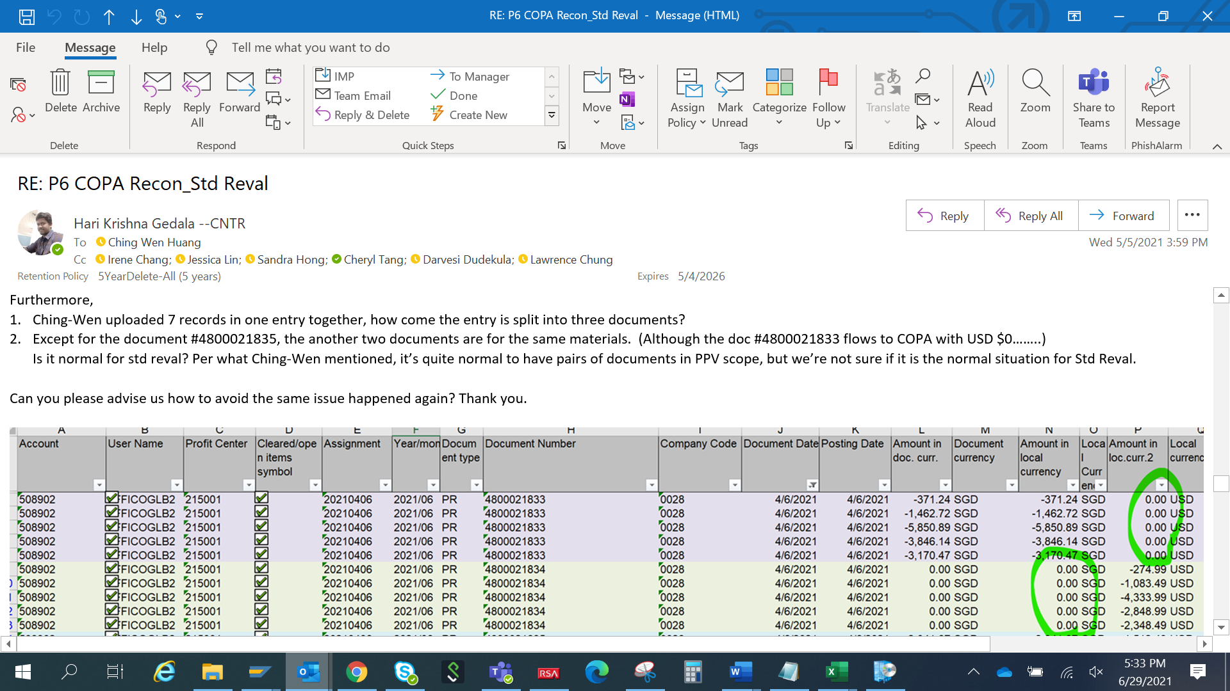
The request is coming to update std cost for 7 parts.
What I did:
First I did the LC marking and release for 3 parts(1 doc posted)
Next I run the costing for another 3 parts(another doc posted)
Next I run the costing via ck11n and ck24(another doc posted)
There is totally 3 doc posted causing Copa recon issue.

Correct steps: LC marking, GC marking, then release LC, no need to release GC

Issue 9:
Std cost revaluation issue due to always re cost check mark in ck40n.
Issue: consultants click on the check box while updating std costing, causing revaluation issue
Sol: re costing will be done in year ending and that need to be done by business user, not from support side, so while using ck40n do not click the always recost
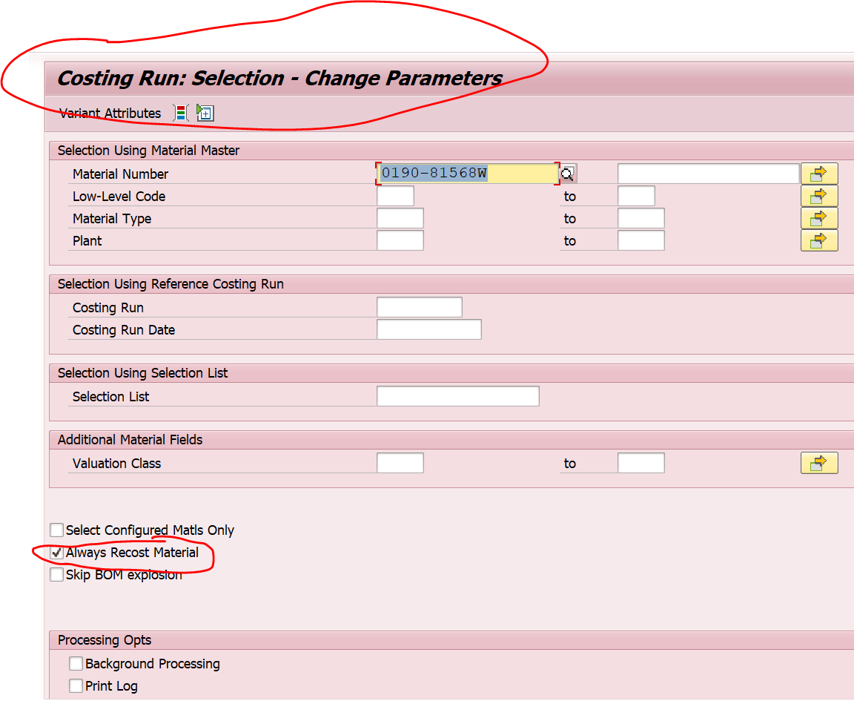

Issue 10.

